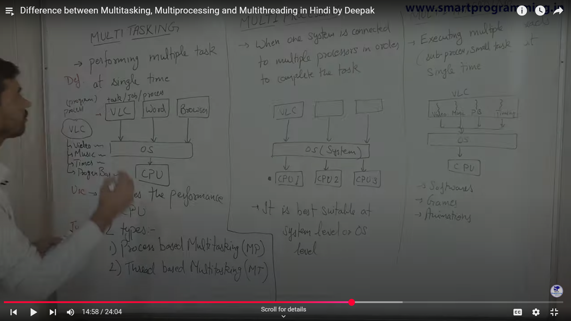

Thread based multitasking is Multithreading

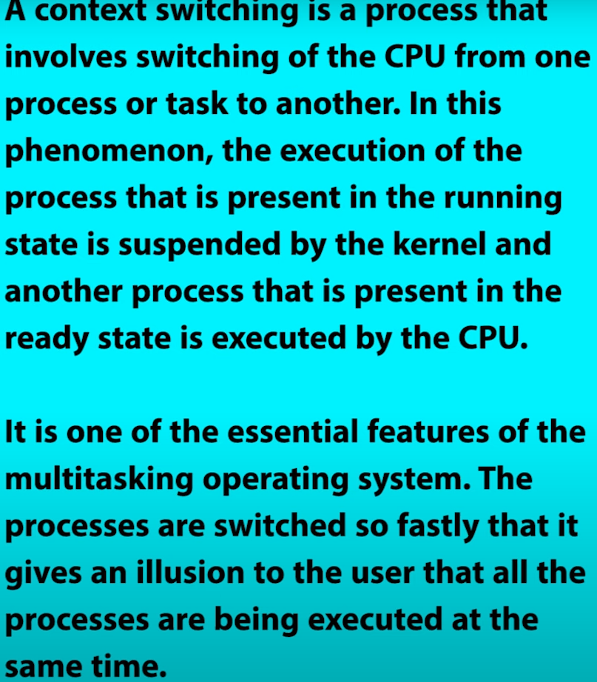

\*\*\*main() is a thread created by JVM

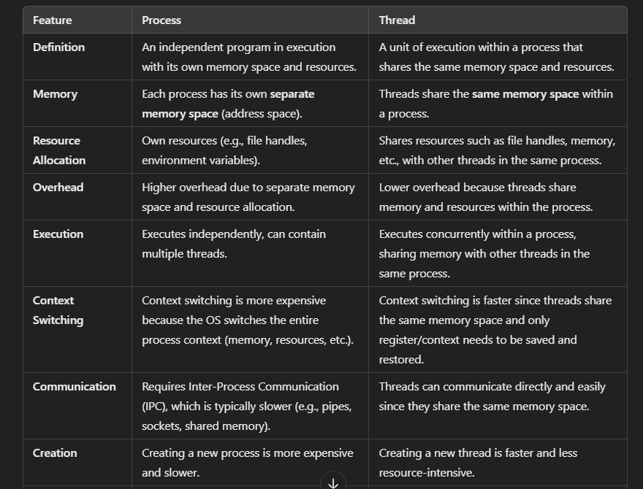

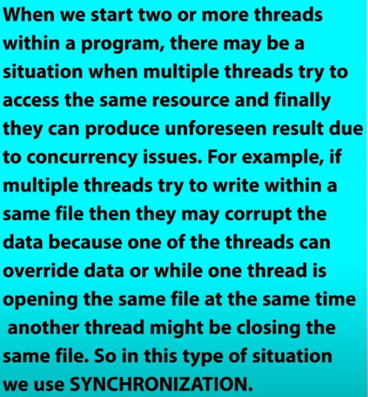

Two ways to create threads 🡪 1. Thread Class 2. Runnable Interface

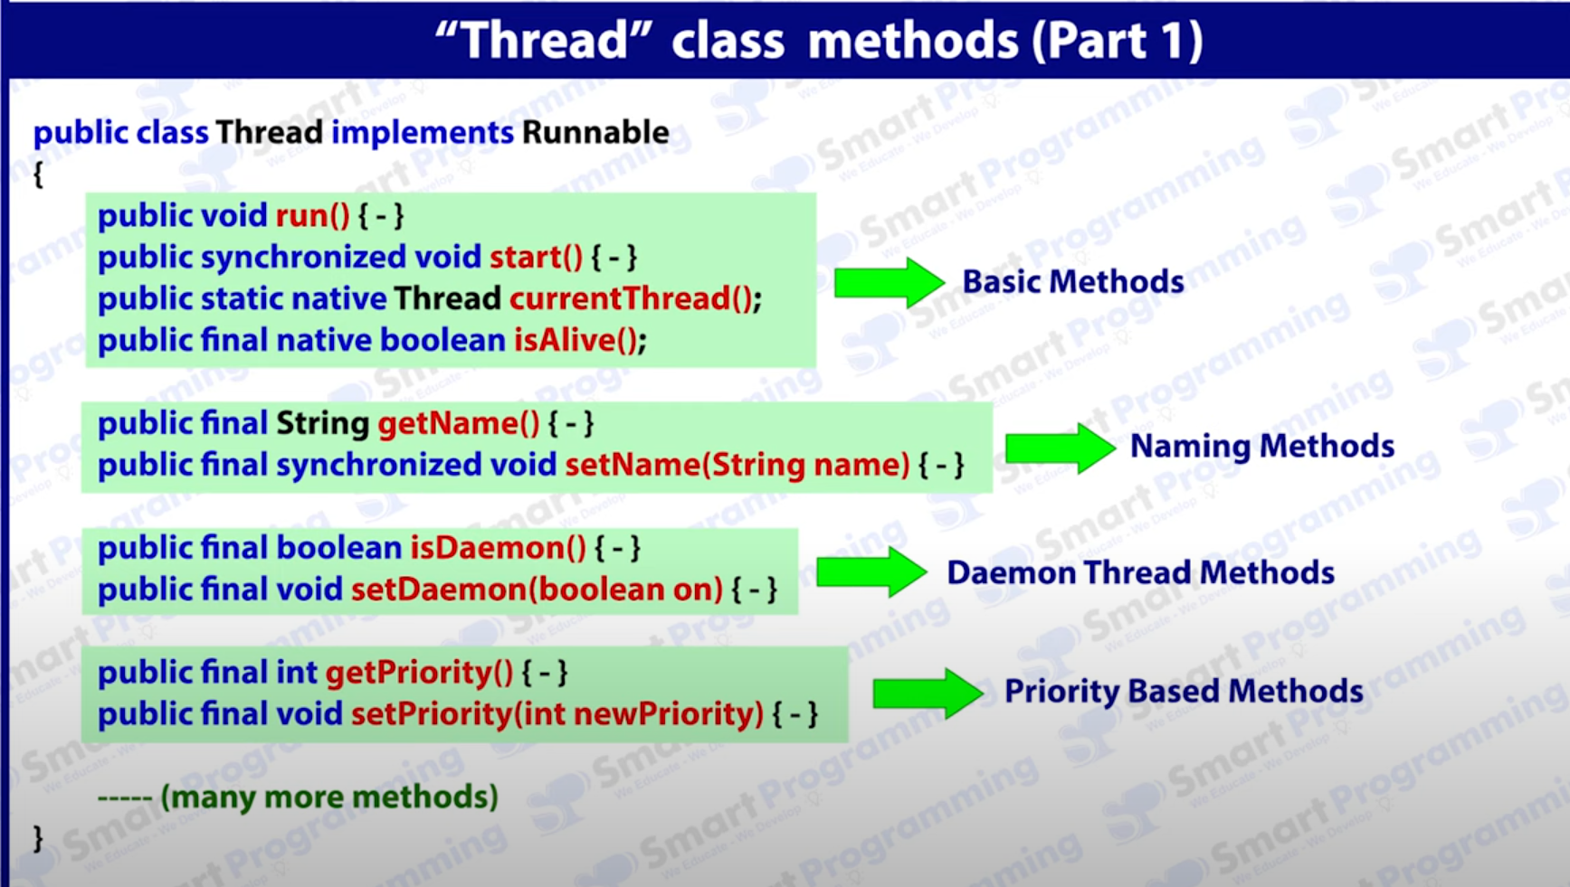

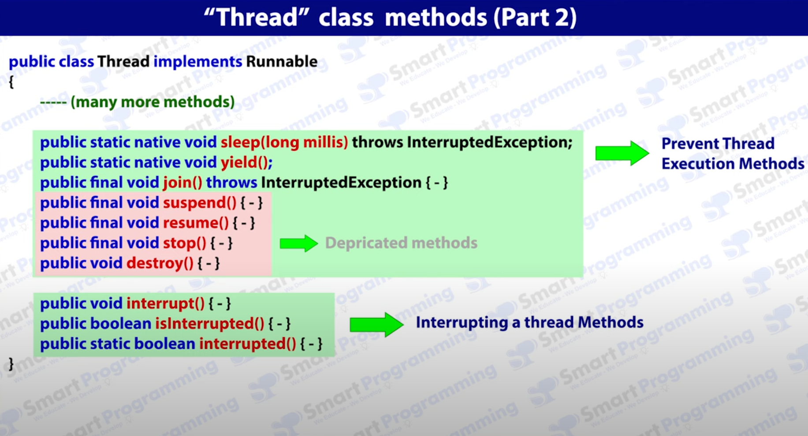

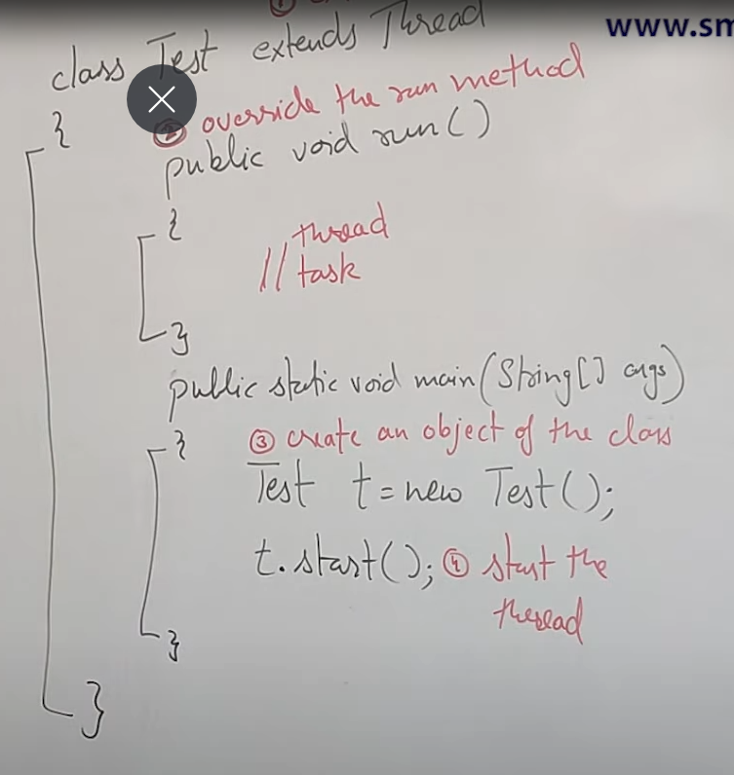

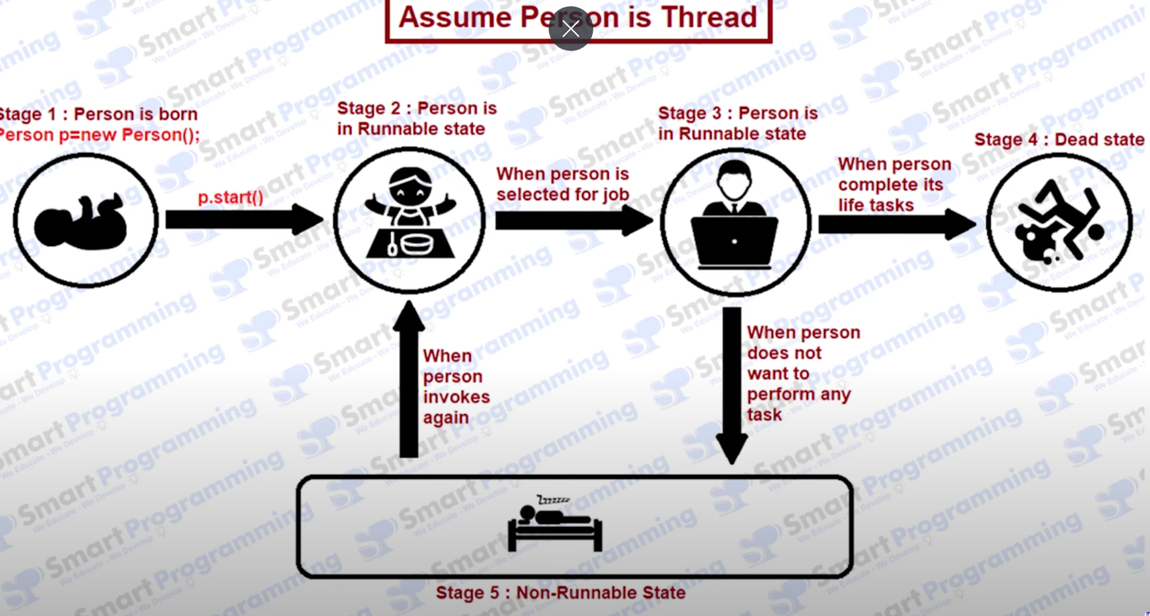

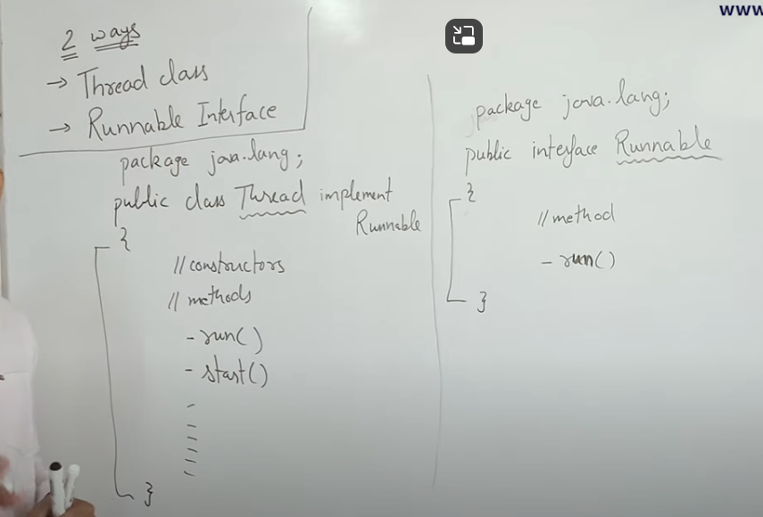Can we call start method more than one for the same object?

Ans. No, as the thread finishes it’s task it will be dead, so, it can’t be invoke again.

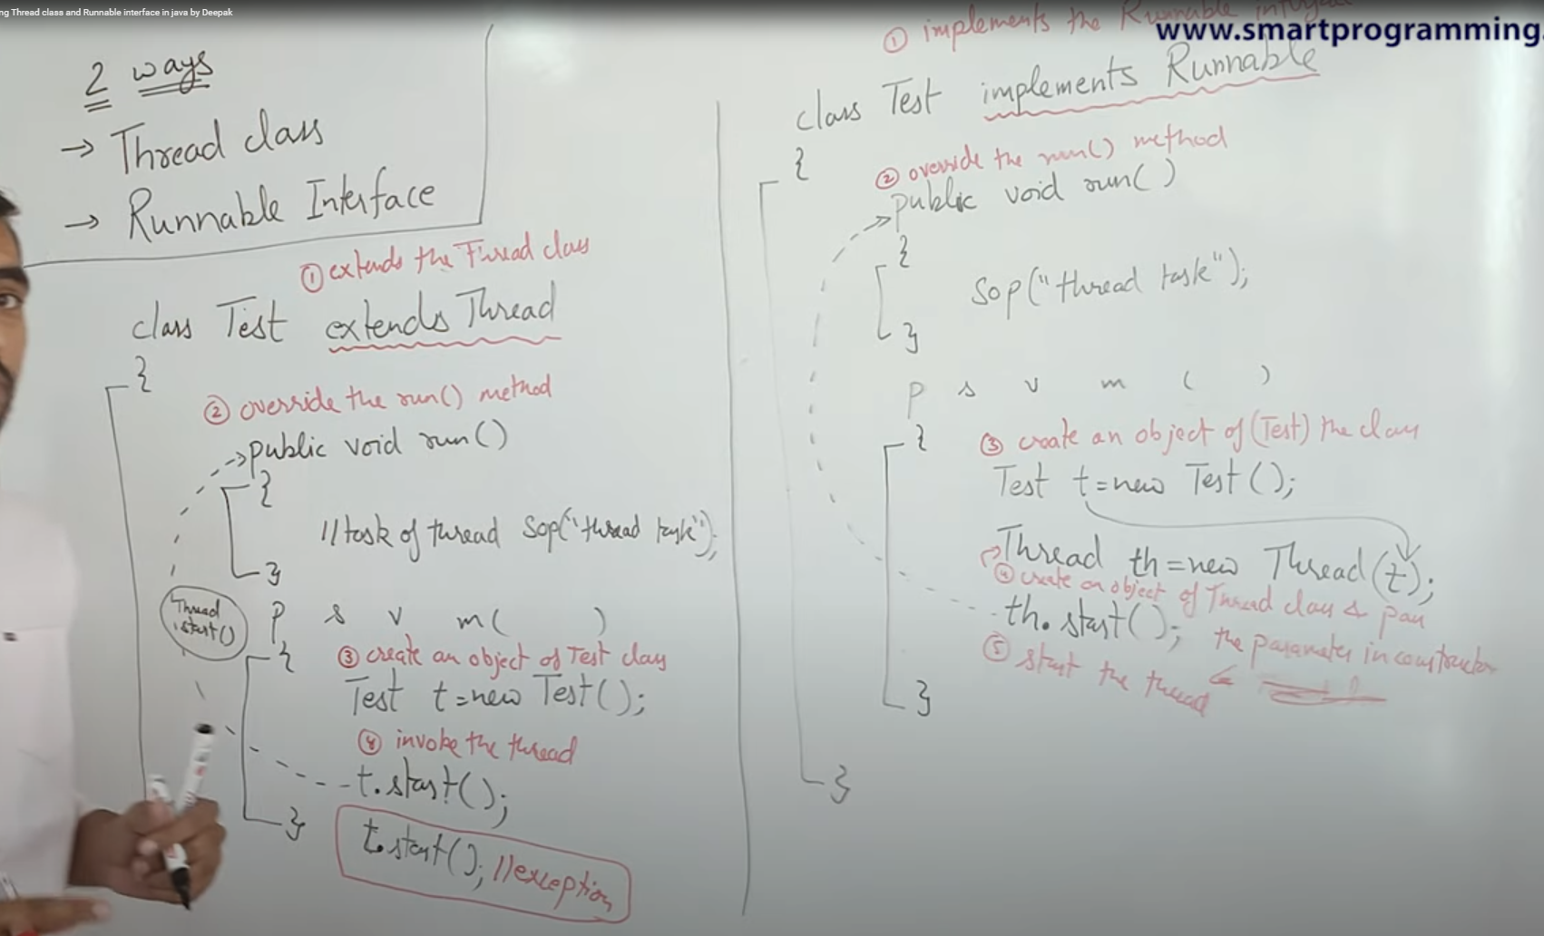

Q. Which one is better: Thread vs Runnable?

Ans. Runnable.

Ex. Class A extends B {} 🡪 I want to make A class a thread but I can’t extend Thread Class here so as java does not support multiple inheritance so the only option left is using Runnable interface.

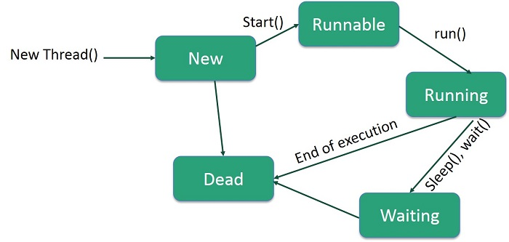

THREAD EXECUTION CASES

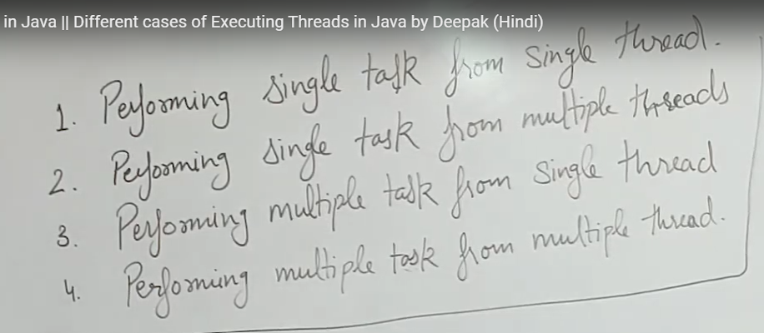

1. Performing single task from single thread.

Ans.

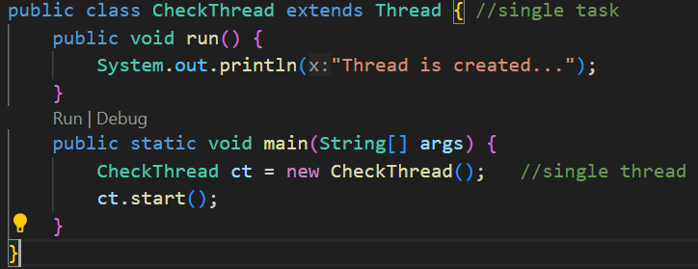

Thread-0 is created by main (naming is also done by main) thread and main thread is created by JVM (naming is also done by JVM).

1. Performing single task from multiple thread.

Ans.

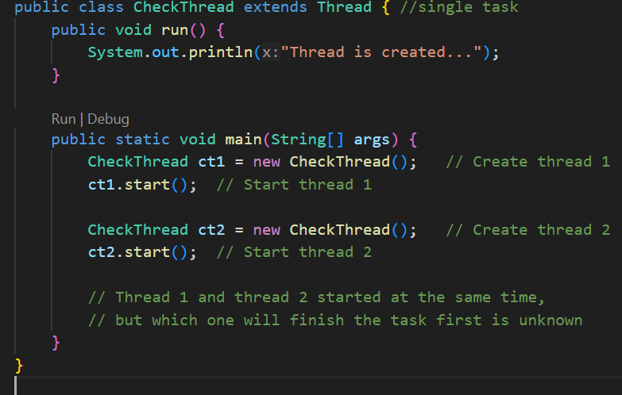

1. Performing multiple tasks from single thread.

Ans. Not possible.

1. Performing multiple tasks from multiple thread.

Ans.

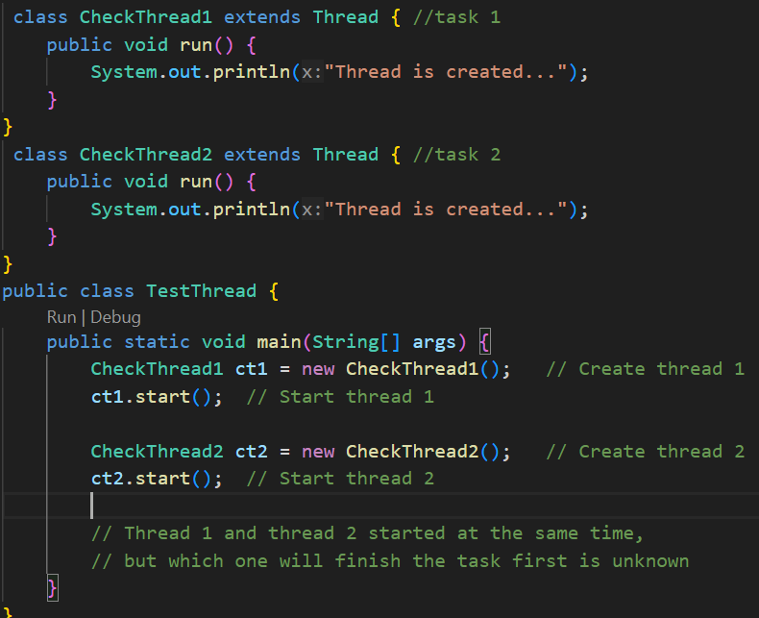

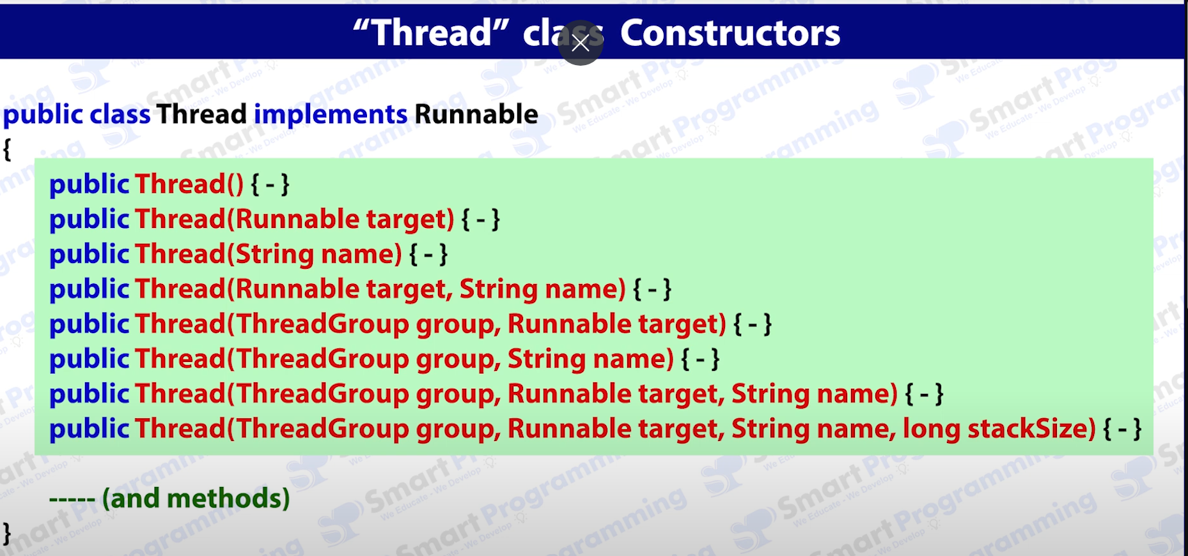

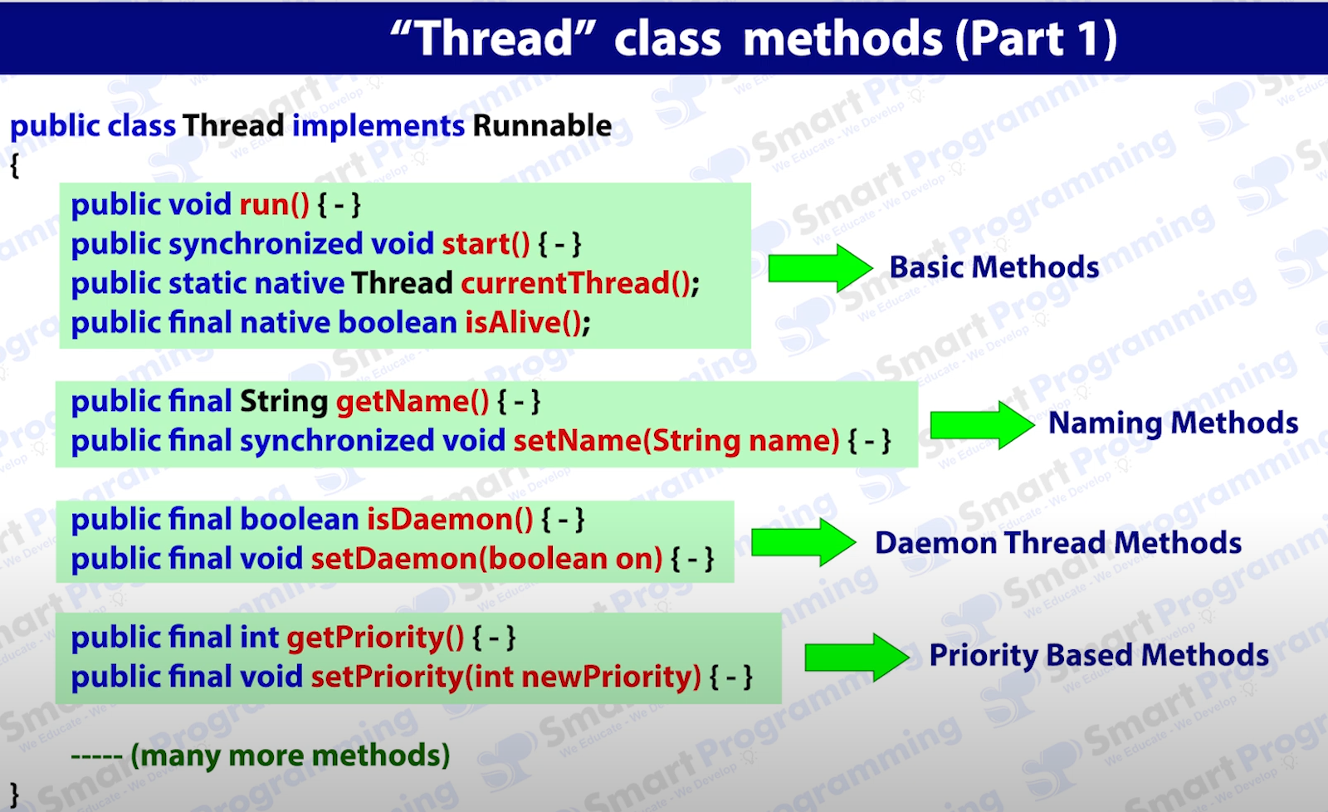

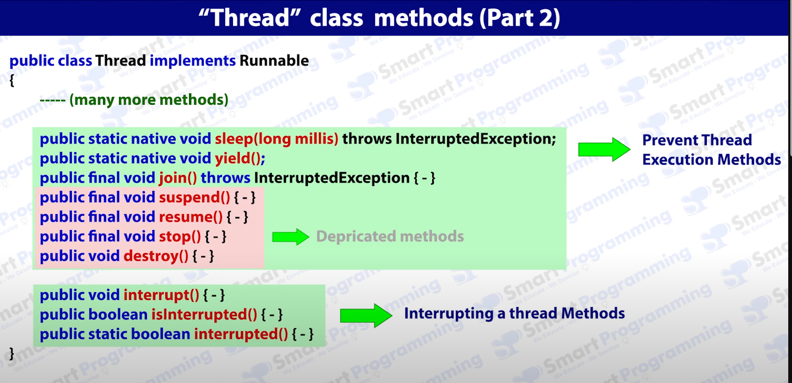

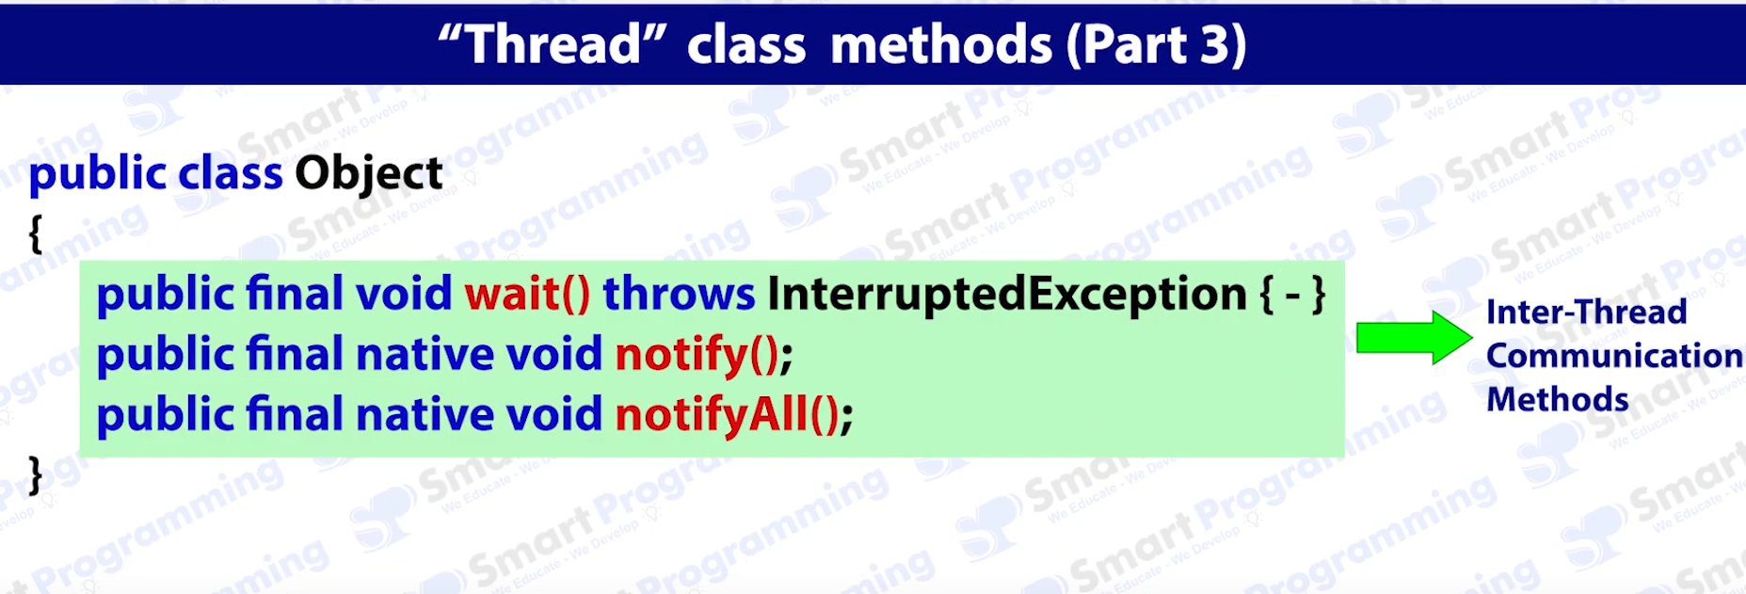

currentThread() is a static method used to get current thread reference.

In Java, a daemon thread is a background thread that supports the execution of user threads by providing auxiliary services. It doesn't prevent the JVM from exiting when all non-daemon threads have finished, and is typically used for tasks like garbage collection or monitoring.

It provides services to threads.

Ex. Garbage Collector, finalizer, Attach Listeners, Singal dispatchers

HOW TO CREATE DEAMON THREAD

Test t = new Test();

t.setDeamon(true);

t.start();

RULE 1:

t.setDeamon(true);

t.start();

// if you do the opposite then it will throw exception

